**NAME**:V.PRITHINGA

**REG NO**:815120106013

**COLLEGE**:8151-DHANALAKSHMI SRINIVASAN INSTITUTE OF TECHNOLOGY SAMAYAPURAM TRICHY.

**NAAN MUDHALVAN COURSE**:DIGITAL MARKETING

**NMID**:D1F12A6C636CEFD85AC4A56D20B489C0

**ASSIGNMENT ON DIGITAL MARKETING**

**1.Create a blog or website using blogspot and wordpress.**

**Customize the theme design and post new atricle with 500 words.**

[**https://wordpress.com/post/lovelycafe29.wordpress.com/6**](https://wordpress.com/post/lovelycafe29.wordpress.com/6)

**2.Create a New Facebook Business Page and post one Social media poster for your brand.**

[**https://www.facebook.com/people/lovely-cafeteria/61550070275469/**](https://www.facebook.com/people/lovely-cafeteria/61550070275469/)

**3.Create a design a Social media advertisement poster using canva**

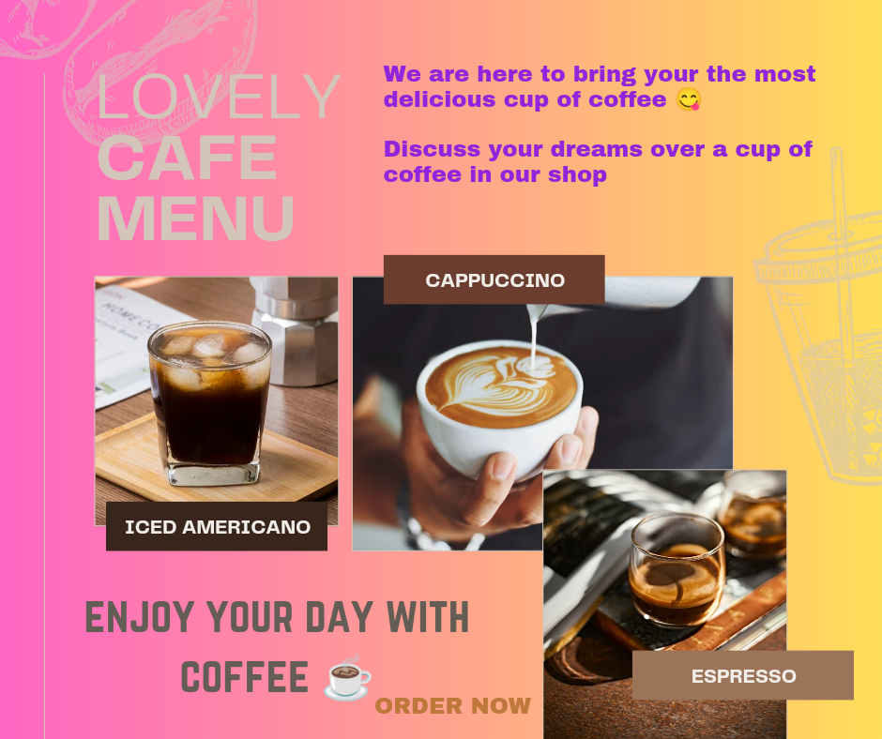

**4.Create email news letter design using Mailchimp or canva tool.**

